6CS029 Workshop 4 - Configuring Basic DHCPv4 on a Router
Topology
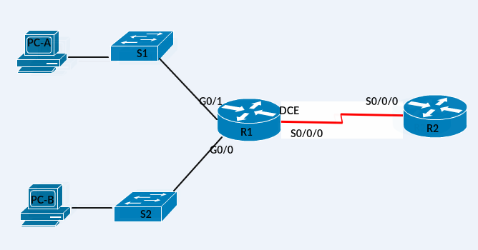
Addressing Table
Device | Interface | IP Address | Subnet Mask | Default Gateway
R1 | G0/0 | 192.168.0.1 | 255.255.255.0 | N/A
 | G0/1 | 192.168.1.1 | 255.255.255.0 | N/A
 | S0/0/0 (DCE) | 192.168.2.253 | 255.255.255.252 | N/A
R2 | S0/0/0 | 192.168.2.254 | 255.255.255.252 | N/A
PC-A | NIC | DHCP | DHCP | DHCP
PC-B | NIC | DHCP | DHCP | DHCP
Objectives
Part 1: Build the Network and Configure Basic Device Settings
Part 2: Configure a DHCPv4 Server and a DHCP Relay Agent
Part 3: Configure a DHCPv4 Server and a DHCP Relay Agent on a different topology

Background / Scenario
The Dynamic Host Configuration Protocol (DHCP) is a network protocol that lets network administrators manage and automate the assignment of IP addresses. Without DHCP, the administrator must manually assign and configure IP addresses, preferred DNS servers, and default gateways. As the network grows in size, this becomes an administrative problem when devices are moved from one internal network to another.
In this scenario, the company has grown in size, and the network administrators can no longer assign IP addresses to devices manually. Your job is to configure the R2 router to assign IPv4 addresses on two different subnets connected to router R1.
Note: This lab provides minimal assistance with the actual commands necessary to configure DHCP. However, the required commands are as you used in 5CS032. Test your knowledge by trying to configure the devices without referring to the appendix.

Note: Make sure that the routers and switches have been erased and have no startup configurations.
- Build the Network and Configure Basic Device Settings

  - Cable the network as shown in the topology.
  - Initialize and reload the routers and switches.
  - Configure basic settings for each router.
    - Configure the host name as shown in the topology.
    - Configure the IPv4 addresses on the router as shown in the topology.
    - Set the DCE serial interfaces with a clock rate of 128000.
  - Configure dynamic routing on the routers.
    - Configure RIPv2 for R1.
R1(config)# router rip
R1(config-router)# version 2
R1(config-router)# network 192.168.0.0
R1(config-router)# network 192.168.1.0
R1(config-router)# network 192.168.2.252
R1(config-router)# no auto-summary
    - Configure RIPv2 on R2.
  - Verify network connectivity between the routers.
If any pings between routers fail, correct the errors before proceeding to the next step. Use show ip route and show ip interface brief to locate possible issues.
  - Verify the host PCs are configured for DHCP.
- Configure a DHCPv4 Server and a DHCP Relay Agent
To automatically assign address information on the network, you will configure R2 as a DHCPv4 server and R1 as a DHCP relay agent.
  - Configure DHCPv4 server settings on router R2.
On R2, you will configure a DHCP address pool for each of the R1 LANs. Use the pool name R1G0 for the G0/0 LAN and R1G1 for the G0/1 LAN. You will also configure the addresses to be excluded from the address pools. Best practice dictates that excluded addresses be configured first, to guarantee that they are not accidentally leased to other devices.
Exclude the first 9 addresses in each R1 LAN starting with .1. All other addresses should be available in the DHCP address pool. Make sure that each DHCP address pool includes a default gateway.
Router R2
R2(config)# ip dhcp excluded-address 192.168.0.1 192.168.0.9
R2(config)# ip dhcp excluded-address 192.168.1.1 192.168.1.9
R2(config)# ip dhcp pool R1G1
R2(dhcp-config)# network 192.168.1.0 255.255.255.0
R2(dhcp-config)# default-router 192.168.1.1
R2(dhcp-config)# exit
R2(config)# ip dhcp pool R1G0
R2(dhcp-config)# network 192.168.0.0 255.255.255.0
R2(dhcp-config)# default-router 192.168.0.1

On PC-A or PC-B, open a command prompt and enter the ipconfig /all command. Did either of the host PCs receive an IP address from the DHCP server? Why?
____________________________________________________________________________________
  - Configure R1 as a DHCP relay agent.
Configure IP helper addresses on R1 to forward all DHCP requests to the R2 DHCP server.
On the lines below, write the commands necessary to configure R1 as a DHCP relay agent for the R1 LANs.
Router R1
R1(config)# interface g0/0
R1(config-if)# ip helper-address 192.168.2.254
R1(config-if)# exit
R1(config-if)# interface g0/1
R1(config-if)# ip helper-address 192.168.2.254

  - Record IP settings for PC-A and PC-B.
On PC-A and PC-B, issue the ipconfig /all command to verify that the PCs have received IP address information from the DHCP server on R2. Paste a copy of the IP configurations below

_______________________________________________________________________________________
Portfolio Task - Based on the DHCP pool that was configured on R2, what are the first available IP addresses that PC-A and PC-B can lease?
_______________________________________________________________________________________
  - Verify DHCP services and address leases on R2.
    - On R2, enter the show ip dhcp binding command to view DHCP address leases.
Portfolio task - Along with the IP addresses that were leased, what other piece of useful client identification information is in the output?
__________________________________________________________________________________

    - On R2, enter the show ip dhcp pool command to view the DHCP pool settings.
Portfolio task - In the output of the show ip dhcp pool command, what does the current index refer to?
    - Portfolio Task – What is a DHCP relay agent and why is it needed?
____________________________________________________________________________________

Demonstrate this to your tutor that it works and have a mark recorded.

Follow the same procedure as above and configure DHCPv4 for the network with the topology shown below and with the following requirements
R1 should serve as the DCHP server for the 100.1.1.0/24 network
R2 should serve as the DHCP server for the 200.2.2.0/24 network
The first 5 addresses in the pools should be excluded
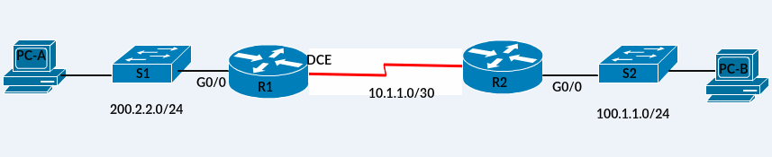 On PC-A and PC-B, issue the ipconfig /all command to verify that the PCs have received IP address information from the DHCP server on R2. Paste a copy of the IP configurations below

Demonstrate this to your tutor that it works and have a mark recorded.

Portfolio Tasks are marked and you should copy your answers into that final portfolio document.

Research Questions which should added to your portfolio tasks

What are the strengths and weaknesses of the DNS and associated servers?

